OPERATIONS
KS1 – 2001 Paper
1.
3 and 6

2.
+
-
-

3.
0

KS1 – 2002 Paper
4.
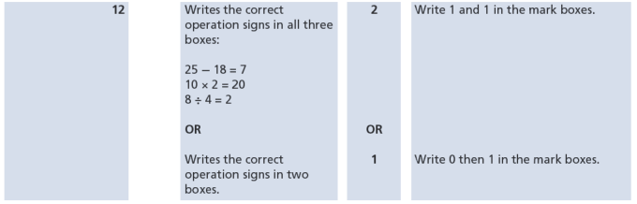
KS1 – 2003 Paper 1
5.
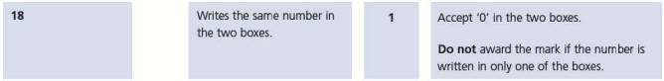
6.
KS1 – 2003 Paper 2
7.
8.
9.
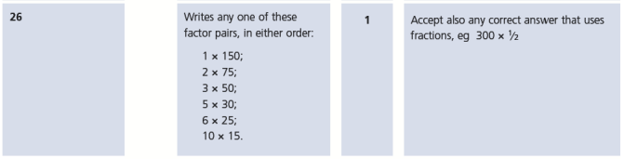
KS1 – 2004 Paper 2
10.
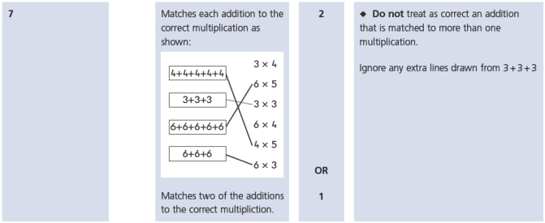
KS1 – 2005 Paper 2
11.
The first and the last number must be the same.
The middle number must be the first number multiplied by 2
Ex. 6 x 2 12 / 2 6 etc.

KS1 – 2007 Paper 1
12.
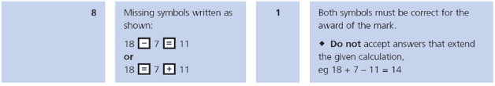
13.
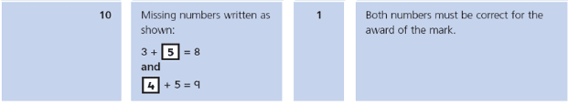

KS1 – 2009 Paper 2
14.
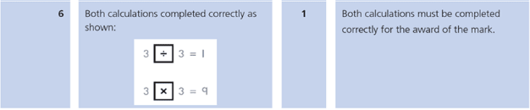
15.
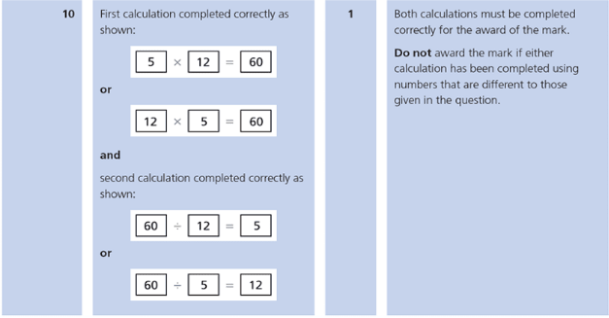
KS1 – 2016 Paper - Reasoning
16.
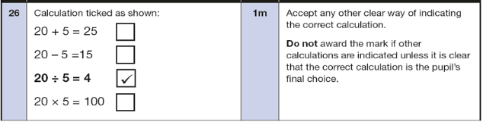
17.
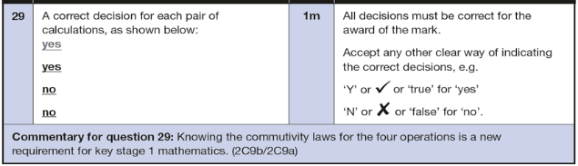
KS1 – 2016 Paper – Reasoning (Second)
18.
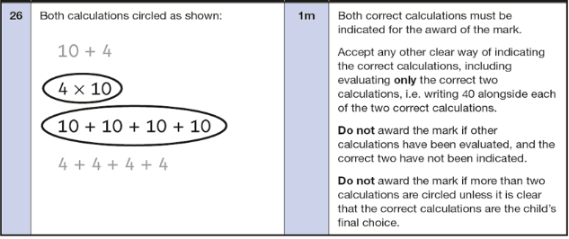
19.
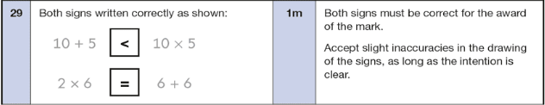
KS1 – 2018 Paper – Reasoning
20.
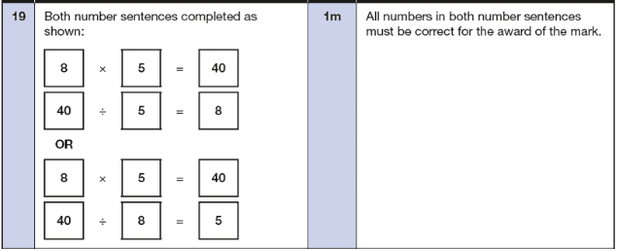
KS1 – 2019 Paper – Reasoning
21.
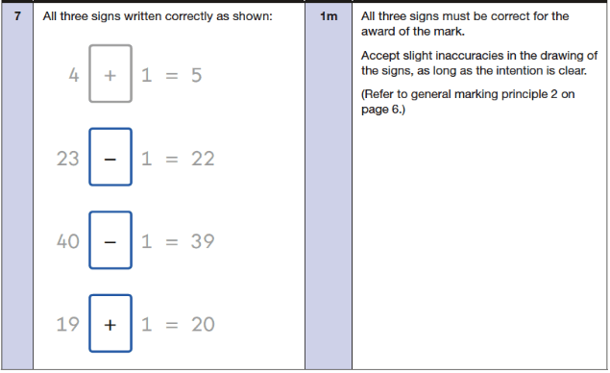
22.
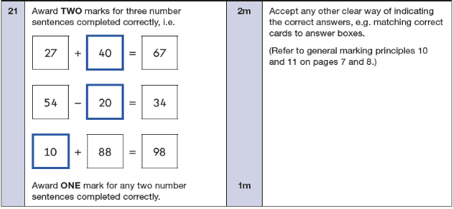
KS1 – 2022 Paper – Reasoning
23.
